**Experiment - 1.1**

**Student Name: Milan Sharma UID: 23MAI10003**

**Branch: ME – CSE - AIML Section/Group: MAI – 1 (A)**

**Semester: 1st Date of Performance: 23 Aug 2023**

**Subject Name: Python Programming Subject Code: 23 CSH 623**

1. **Aim of the Experiment :**

Installation of Python and understanding of basic syntax and semantic rules.

1. **Objective of the Experiment :**

How to install Python IDE

1. **Algorithm/ Steps for Experiment :**

1 :- To install Ancondas.

1.1 :- Visit Official Site: <https://www.anaconda.com/> and click on Download button as shown in below image.

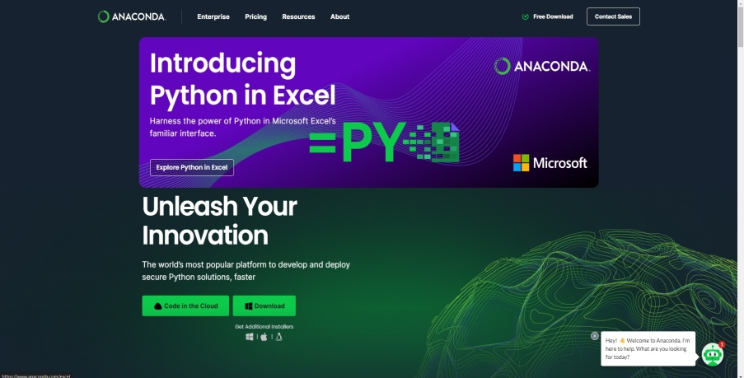

1.2 :- Click on the setup file to start installation as below shown

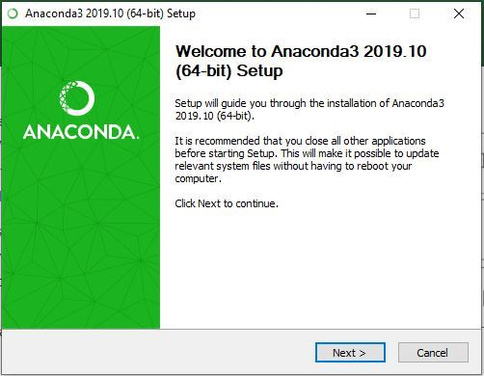

1.3 :- Getting through the licence agreement

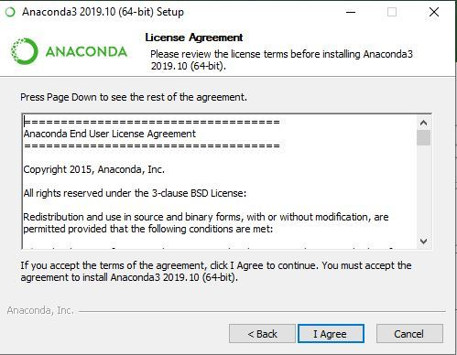

1.4 :- Select installation type for e.g. (Just for me)

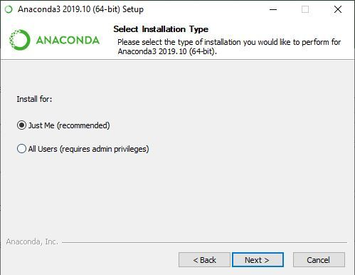

1.5 :- Choose installation location

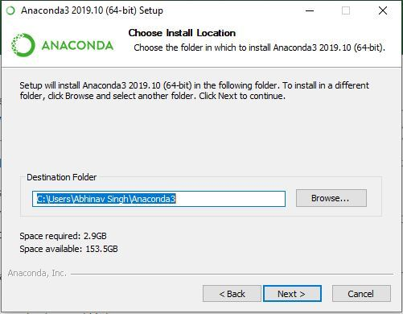

1.6 :- Getting through installation process and finish the installation.

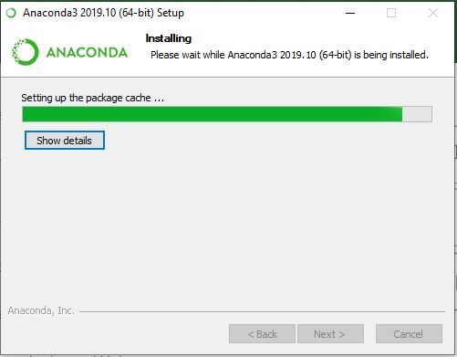

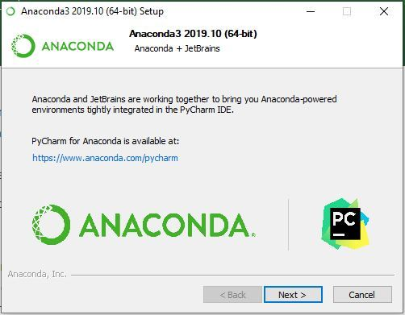

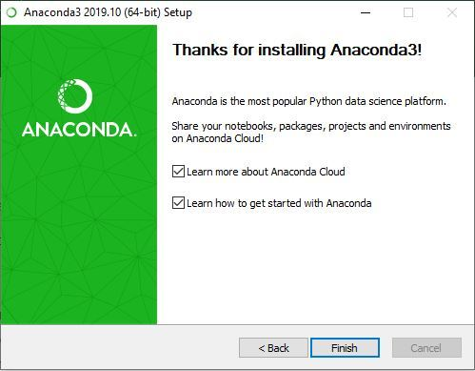

2 :- Installing Jupyter

2.1 :- Now Launch Anaconda Navigator (for installing Jupyter)

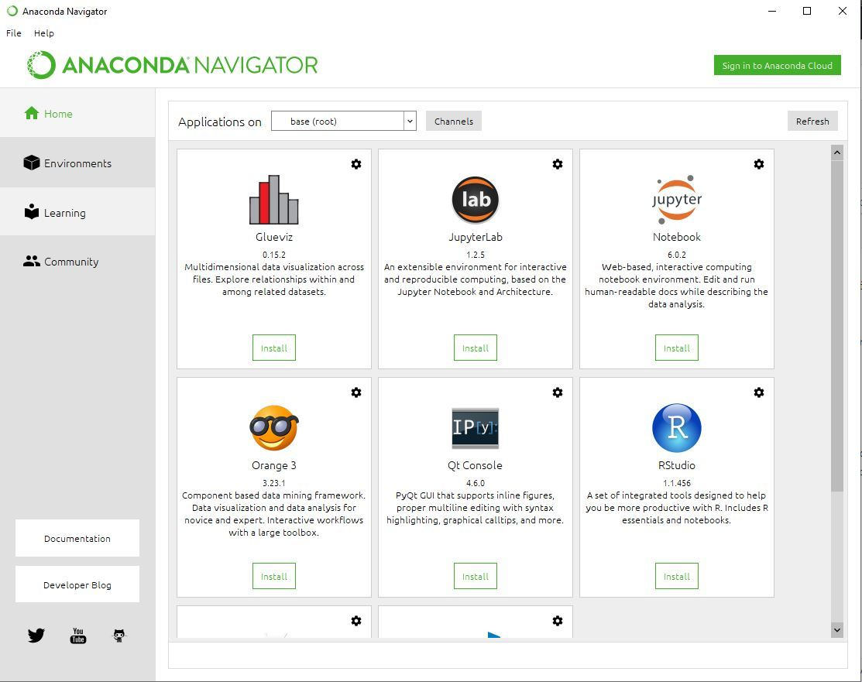

2.2 :- Click on install Jupyter Notebook button as shown in the image below

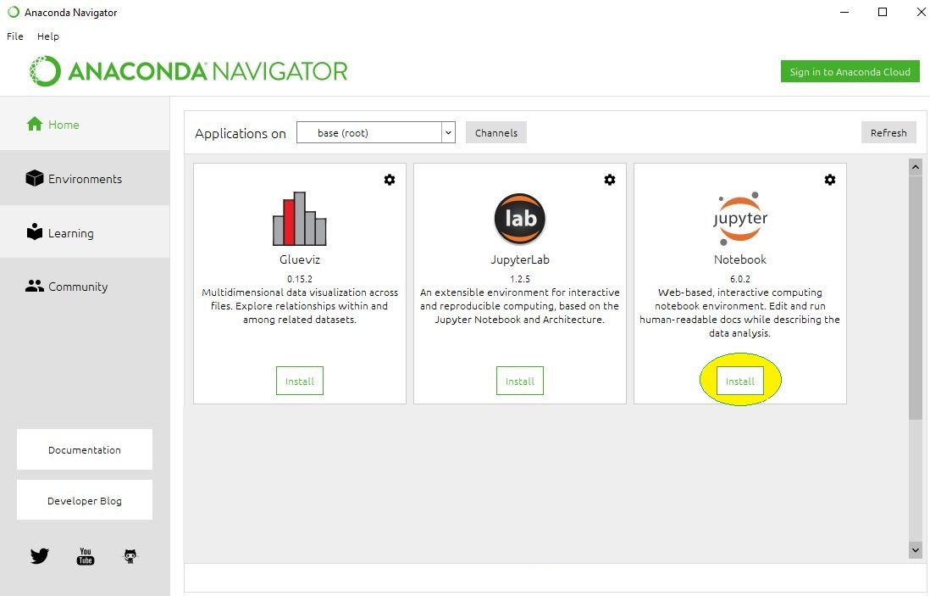

2.3 :- Begin the installation

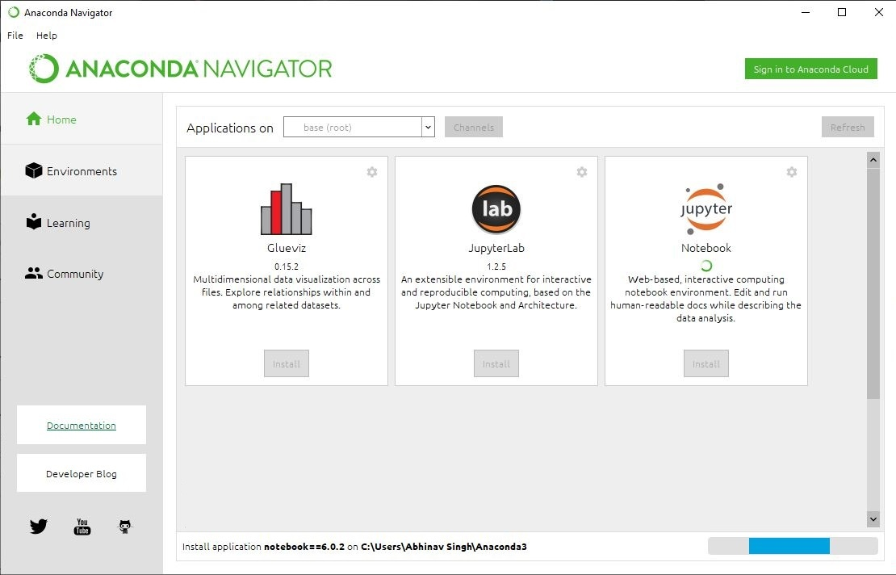

2.4 :- Loading Packages

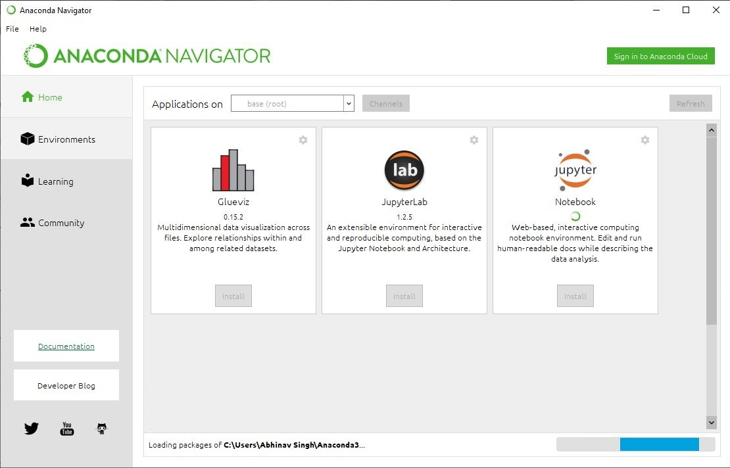

2.5 :- Finishing installation and Launching Jupyter

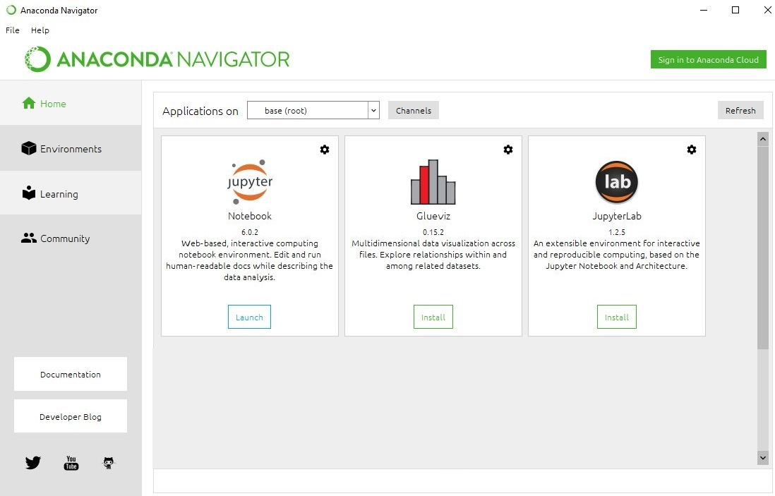

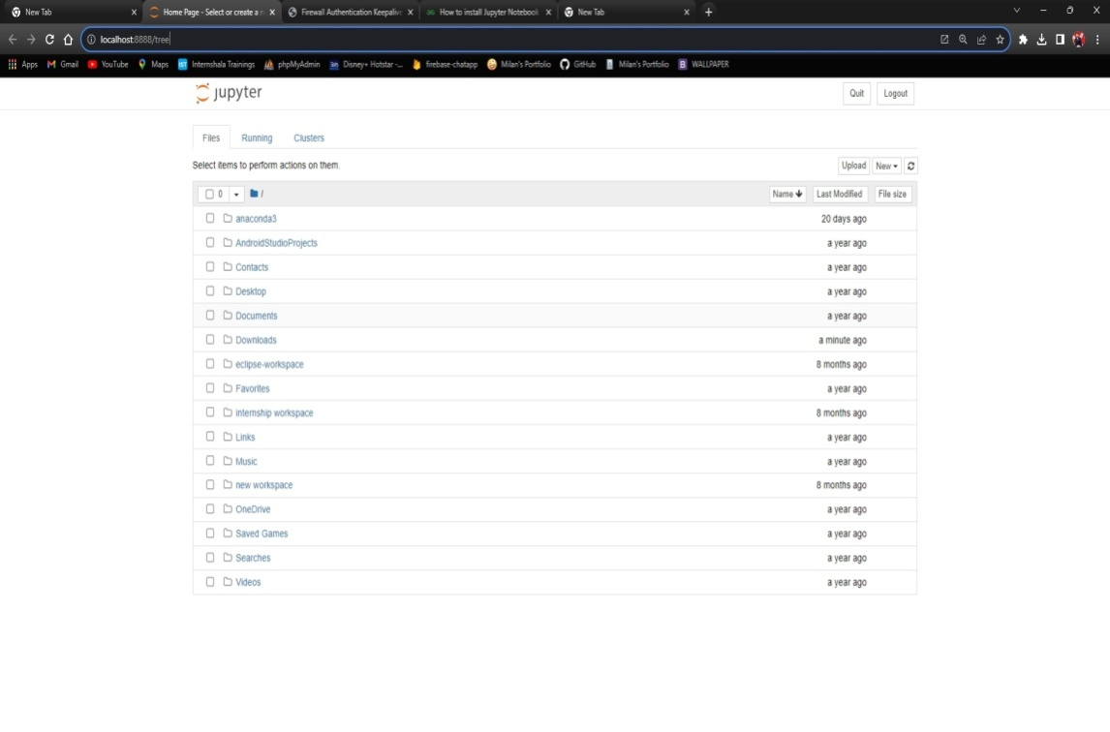

**Learning outcomes (What I have learnt):**

**1.** Learned how to install Python IDE (Jupyter Notebook) using Anacondas.

**Evaluation Grid (To be created as per the SOP and Assessment guidelines by the faculty):**

|  |  |  |  |
| --- | --- | --- | --- |
| **Sr. No.** | **Parameters** | **Maximum Marks** | **Marks Obtained** |
| **1.** | **Student Performance**  **(Conduct of experiment)**  **Objectives/Outcomes.** | 12 |  |
| **2.** | **Viva Voce** | 10 |  |
| **3.** | **Submission of Work Sheet**  **(Record)** | 8 |  |